Window Shopper – How to Register

Window Shopper is designed for Georgia State Agencies who are PeopleSoft users who do not have access to the Team Georgia Marketplace applications.

Step # | Do This:
1 | Upon your first visit to Window Shopper, you will need to create a User Name and Password. To do this, click the link that states: If this is your first visit, please register here.  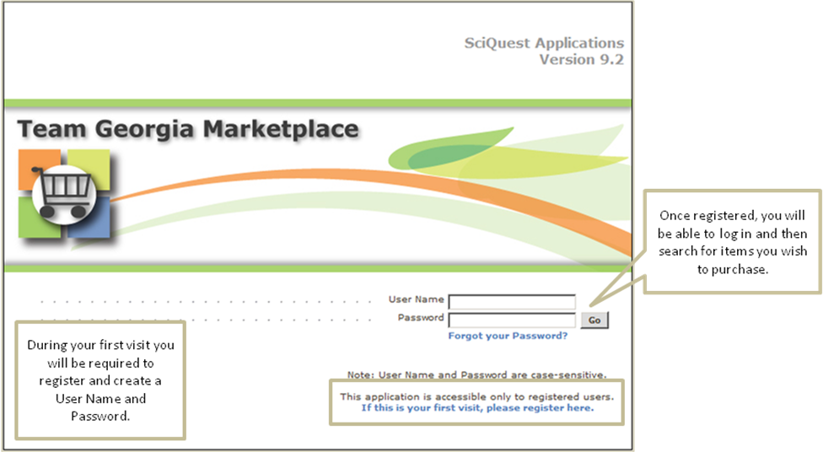
2 | To register, you’ll simply fill in the fields that have an asterisk next to the field name.  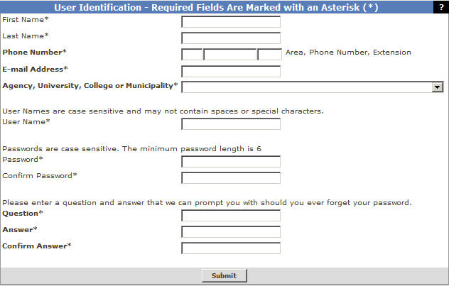

3 | To complete the Agency, University, College or Municipality field, click the drop-down arrow to select your state entity name.  In the example shown, Fulton County is selected.  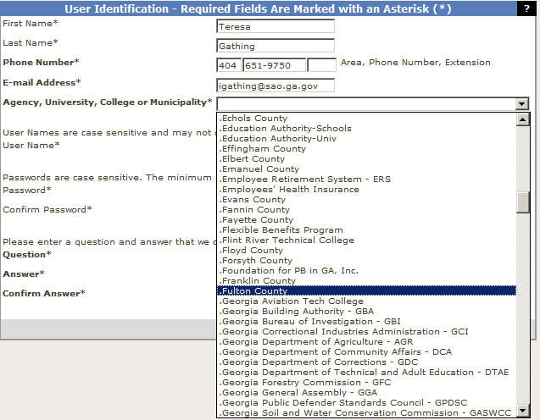
4 | The user name is case sensitive and should only contain alpha and numeric characters. The password is also case sensitive and must contain at least six characters.  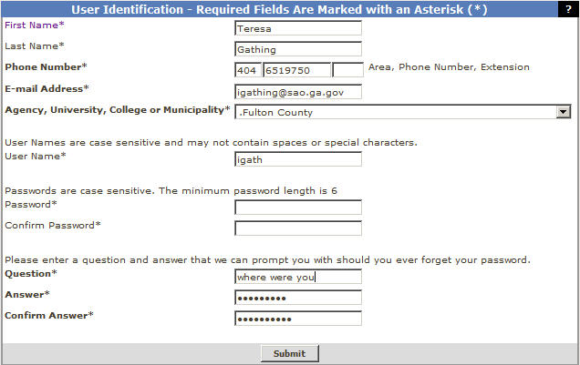  You will also need to create a password question and answer prompt in case you forget your password. The question and answer prompt will be used to help you restore your password.

5 | After you have completed the user information, you will need to accept Terms and Conditions for using window Shopper.  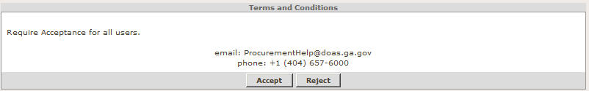
6 | When you accept the Terms and Conditions, expect to wait up to 24 hours for your new User ID  and password.  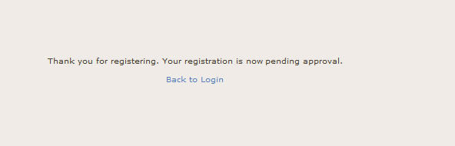
7 | End of Procedure

